PorscHER Ladies of Vancouver Island  Book Club | 
 | 

  - Next Bookclub Meeting
  - December 2 – 6-8pm
  - Where: Shelia’s Home

Information For December 2026 Meeting

Book

In Strangers, Burden revisits her marriage, searching for clues that her husband was not who she always thought he was. As she examines her relationship through a new lens, she reckons with her own family history and the lessons she intuited about how a woman is expected to behave in the face of betrayal. Through all of it, she is transformed. The discreet, compliant woman she once was—someone nicknamed “Belle the Good”—gives way to someone braver, someone determined to use her voice.
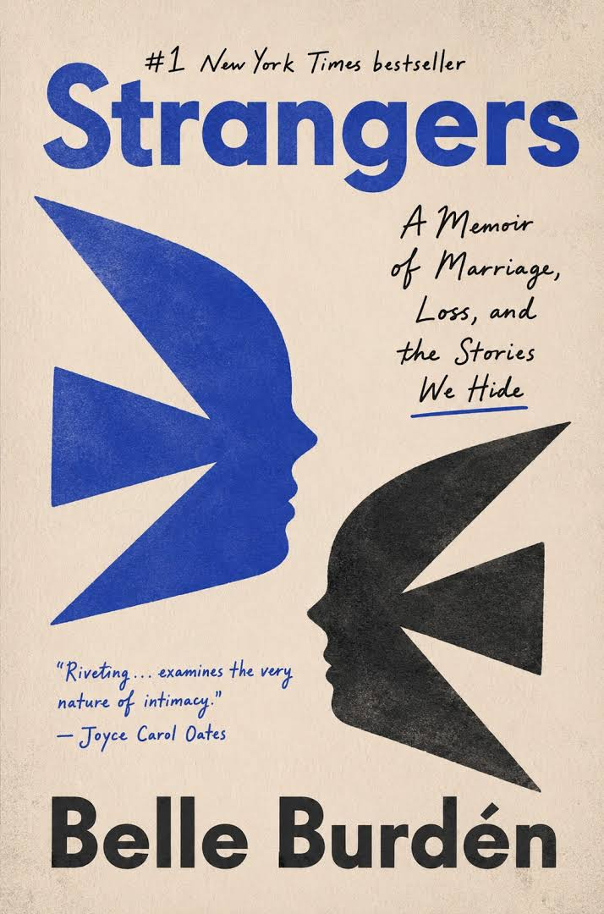

Why
Being part of a book club is a great opportunity to foster social connections, expand reading horizons beyond your usual genres, sharpen your mind with new perspectives, create accountability to read more and have fun and bond with friends in a structured way while exploring important ideas. What a wonderful way for us to continue to build and support a PorscHER community.

Contact
If you are interested in attending, text/WhatsApp Diane Cruickshank at 250-818-3335 or email dmc019@icloud.com

Thank you and as always, I look forward to connecting with this group of inspiring women.

